2018 SRCC Summer Scholarship Program

The Saskatoon Racing Canoe Club is offering summer paddling scholarships to youth aged 9-18. Paddling lessons will take place twice weekly throughout July and August at the Victoria Boathouse in Riversdale. Participants will have the opportunity to paddle kayaks, racing kayaks, stand up paddleboards, dragon boats and racing canoes. The boathouse is a great place to be during the summer months. Make new friends, learn new skills, have fun. All fees waived for successful applicants. Sponsored by: 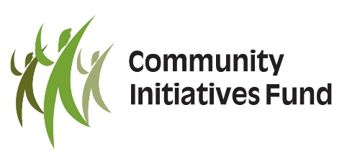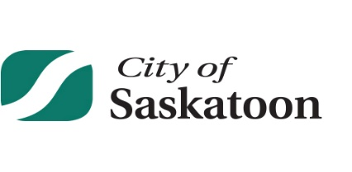
Interested participants should fill out the application on the back. Scholarships are limited. Successful applicants will be notified by June 30th.
We also offer Summer Camps, Youth Lessons and Adult Lessons. Sign up online at:
www.saskatoonracingcanoeclub.com

Saskatoon Racing Canoe Club Scholarship Application

Full Name: _______________________________
Age:______________
School:_________________________________
Teacher:________________________

_________________ ________________
Applicant Signature Parent/Guardian Signature

____________________
Date
Snap a picture of completed applications and send to: carladyck@gmail.com
www.saskatoonracingcanoeclub.com

